An Introduction to Brix | Brix Basics

|Lists|
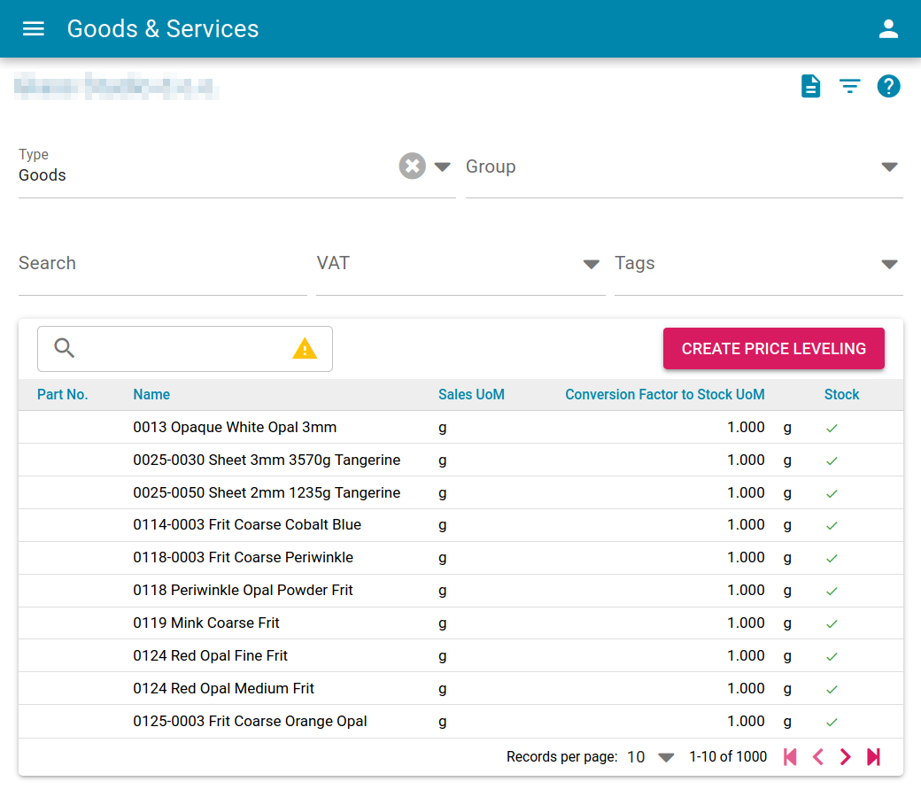

Text search box

The text search field enables searching the listed records for a text match in the displayed data within all pages of the list.

Note
- A yellow warning triangle in the text search box indicates that there are more records in the database than the listed records. The text search only does a search within the listed items and therefore might not show all available records in the dabase. In such an event it is recommended to use the filter to reduce the number of items in the list until the yellow warning triangle disappears and then commence with the text search box.

